Analytical Report

Omega Software Solutions Ltd.

Sampreet Klair

**Introduction and Client Overview:**

In the contemporary world, living without technology is like navigating an unexplored territory without a compass or a map, it cannot be done. Therefore, people creating these technological solutions are pioneers and will thrive in moving forward. The work of small cap consulting firms is to create solutions for small local level businesses and help them with analysis of their business performance. “Consultants help formulate a BI (Business Intelligence) strategy that aligns with the company's business goals and objectives.” (Business Intelligence Consulting & DAFFODIL SOFTWARE , 2024) Our client Mr. Richard Brenno is considering to either start his own tech consulting firm from scratch or buy the existing Omega Software Solutions Ltd. from Mr. David Malan. Our report attempts to provide Mr. Brenno with an answer by analyzing both the options and providing him with a firm conclusion. Omega Software Solutions is a tech consultant firm based of North York in Toronto, Ontario. Currently it has 8 employees excluding the owner Mr. Malan and it also has a good list of clients. It generates an annual revenue of $450,000 and is a profitable business.

**Industry Overview:**

Tech consulting is a very profitable business for the future. It has a promising growth and can provide the business owner with plethora of success. According to cleveroad.com, “The global IT consulting market was valued at USD 273.13 billion in 2022, and it’s expected to expand with compound annual growth rate (CAGR) of 12.1% from 2023 to 2030. The growing adoption of technological trends and ever-rising investment in advanced technologies will increase the demand for IT consulting services.” (Altynpara & Chabanovska, 2024)

Graph showing size of US Software Consulting Market from 2022 to 2030 (expected):

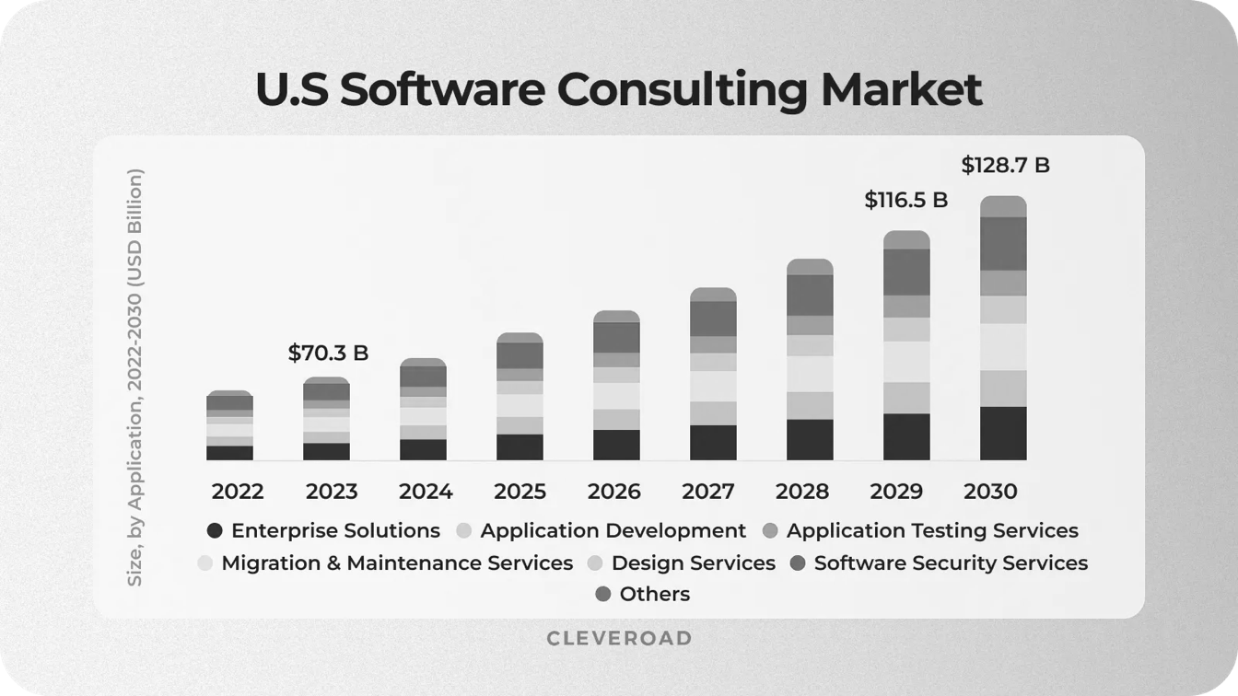(Altynpara & Chabanovska, 2024)

**Advantages of Purchasing Omega Software Solutions Ltd.:**

* **Existing Infrastructure**: By purchasing Omega Software Solutions Mr. Brenno will not only buy the business of Mr. Malan but he will also buy the existing infrastructure that Mr. Malan has created over the years. This includes the office complex leased in the heart of city attracting various business owners from surrounding, a team of 8 employees trained by him who are experienced enough to take forward Omega Software Solutions under the leadership of Mr. Brenno, and a long list of various tech equipment and gadgets needed to run the company.
* **Existing Customers**: With Omega Software Solutions also comes a regiment of their loyal customer base, some of whom are customers since the beginning of this company. One of the major reasons new businesses fail in this industry is the lack of reoccurring customers, but by purchasing Omega Software Solutions these customers are also acquired by the new owner.
* **Immediate Cash Flow**: After the acquisition of Omega Software Solutions, the new owner can expect a steady revenue from the following month thanks to its existing robust cash flow.

**Disadvantages of Purchasing Omega Software Solutions Ltd.:**

* **High Initial Investment**: Buying a business with such good cash flow, in an industry with a promising growth rate, and having existing reoccurring customers does not come with a cheap price. To complete the purchase Mr. Brenno will need a large sum of money which will lead to a very high initial investment.
* **Integration Challenges**: Having a change in management for the entire workforce of Omega Software Solutions will be a discomfort. They have worked with the existing owner from a long time have got a strong sense of trust and stability. After the buyout of the company, Mr. Brenno will have to earn the trust among his coworkers.
* **Client Retention**: It has been observed a plethora of times that with a shift in ownership the clients usually tend to reevaluate their options, which can lead to decrease in revenue, but the new owner can prevent it by showing a sense of intent and reassuring the same quality of work as before if not better.

**Advantages of creating a new Software Consultancy Firm:**

* **Full Control**: By creating a brand-new software consultancy firm Mr. Richard Brenno is creating a business for himself and will have the full control over it. It does not need to be named Omega Software Solutions, he can name his business whatever he wants that aligns with his vision. He can decide what will be the work culture of his company and he will be the one hiring new employees that share his vision and can foster his ambitions.
* **Low Initial Investment**: As mentioned in the disadvantages of previous section, buying an existing successful business needs a lot of initial expenditure, but if Mr. Brenno decides to create his own business, he can control and dictate the flow of investment which can be divided into smaller chunks as required, in contrast to a single large payment.
* **Latest Technology Advantage**: When creating a new business most often the entrepreneurs decided to go with the latest technology according to the industry standards that are supported for long term development and aid the new business owners. The same can be done by Mr. Brenno which will help him in the longer run while doing the business. Moreover, in today’s modern world Mr. Brenno can also take advantage of remote work, “Physical globalisation of IT consulting services means the provision of IT consultants on site, which in turn implies high costs and less flexibility. In contrast, digital globalisation avoids high expenditure on travel and buildings that allow working at a physical location, by investing instead in digital solutions to achieve digital consulting.” (Bode, Daneva, & van Sinderen, 2022)

**Disadvantages of creating a new Software Consultancy Firm:**

* **Uncertain Revenue**: The reason behind failure of most new businesses is the lack of revenue or in some cases creating no revenue. This can a major factor in determining success of Mr. Brenno’s business. By creating a new business, he has a risk of making no revenue but if he purchases an existing one, the existing cash flow of that business can make some money for the business.
* **No Existing Infrastructure**: As mentioned in the advantages of the previous section, purchasing an existing business also means the new owner is purchasing the existing infrastructure developed over the years by the previous owner. So, if Mr. Brenno decides to create a new business from scratch, it also means he will need to create new infrastructure needed for the proper functioning of the new business, that will require a lot more efforts from him.
* **No Current Clients**: One of the major disadvantages that go against creating a new business from beginning is the lack of existing reoccurring clients, that are crucial for sustaining the growth for the business. Creating connections and networks with new clients takes time and effort, in contrast to buying an existing business with existing clients.

**Our Recommendation:**

After going through the pros and cons of Purchasing Omega Software Solutions Ltd. as well as creating a new software consultancy firm from scratch, our team’s recommendation for Mr. Richard Brenno is to buy the existing business of Omega Software Solutions from Mr. David Malan. By doing what we recommend Mr. Brenno can ensure he will have a steady revenue from the first month of being in business because of the existing cash flow of Omega Software Solutions. Moreover, Mr. Brenno will also have a long list of existing reoccurring clients who will ensure he will not go out of business. Moving forward with the existing robust infrastructure of Omega Software Solutions, with time which he can upgrade will be vital in his business’s future growth.

# Bibliography

Altynpara, E., & Chabanovska, D. (2024, January 22). *IT Consulting Hourly Rate in 2024: Full Price Comparison*. Retrieved from cleveroad.com: https://www.cleveroad.com/blog/it-consulting-rates/#:~:text=The%20global%20IT%20consulting%20market,demand%20for%20IT%20consulting%20services.

Bode, M., Daneva, M., & van Sinderen, M. J. (2022, July 12). *Characterising the digital transformation of IT consulting services–Results from a systematic mapping study*. Retrieved from The Institute of Engineering and Technology: https://ietresearch.onlinelibrary.wiley.com/doi/10.1049/sfw2.12068

Business Intelligence Consulting & DAFFODIL SOFTWARE . (2024). *Business Intelligence Consulting*. Retrieved from Zenodo: https://doi.org/10.5281/zenodo.10985332